Creating a PDF Connector - Developer’s Guide

Contents
Overview 3
Key Files and Their Purpose 3
✅ Menu.cs 3
✅ Connector.cs 3
✅ ConfigurationControl.cs 3
✅ Resources.resx 3
Adding a Menu in PPDF 4
File: Menu.cs 4
Steps to Add a Custom Menu Item: 4
Required Methods to Implement in Connector.cs 5
Changes in ConfigurationControl.cs 6
Change GuidAttribute 6
Build Settings 7
Release 7
Deploying the Connector 8
Copy DLL and its Dependencies 8
Modify PublishMode.xml 8
Add Group Name 9
Register DLL 9
Clear Cache 9

Overview
This document outlines the essential components and steps involved in creating a custom PDF connector using the CurrentDocumentBluePrint template. This general guide helps developers understand the extensibility points and where to plug in their logic.
The CurrentDocumentBluePrint is a .NET Framework-based project that integrates into Power PDF to extend functionality for custom actions such as opening, saving, and processing PDF documents.

Key Files and Their Purpose

✅ Menu.cs
- Defines custom toolbar/menu items via MenuItemDefinition.
- Handles icon resources and user interaction.

✅ Connector.cs
- Implements DMSConnecor interface.
- Entry point for document events: DocAddNew, DocOpen, DocSave.
- Handles initialization and global logic.

✅ ConfigurationControl.cs
- Optional configuration dialog.
- Can be used to collect or store user preferences like settings, URLs.

✅ Resources.resx
- Stores icons and string resources used in the UI.

Adding a Menu in PPDF

File: Menu.cs
This file contains the MenuItemDefinition class and a static array menuDefinitions that defines what menu items will appear in the Power PDF toolbar or menu for your connector.

Steps to Add a Custom Menu Item:
- Define an entry in enum:
public enum ItemId
{
OPEN = 1,
SAVE = 2,
CUSTOMACTION = 3
}
- Add a Resource String: In Resources.resx (under Resources folder), add:
  - MenuCustomAction → value: "Run Custom Task"
- Add Bitmap Resources if required:
  - Add icons (e.g., Image_Custom.png) to your Resources.resx.
- Add Entry to menuDefinitions :
new MenuItemDefinition(ItemId.CUSTOMACTION, "MenuCustomAction",
"Perform a custom task", true, CallbackType.CALLBACK_MENUITEM,
"Image_Custom", "Image_Custom_150", "Image_Custom_200",
"Image_Custom_Small", "Image_Custom_Small_150", Image_Custom_Small_200", true)
- Make sure your image names match what’s used in Resources.resx. If required add new icons to Resources.resx.

Required Methods to Implement in Connector.cs
Following methods can be implemented or added code as required :
- string DocAddNew(string sourceFile, string title, string[] docProperties)

- This is the first method to be executed if added Menu Item is of CallBackType -> CallBack_Save
- Here you have access to document path and other document properties.
- All logic related to document processing can be placed here.

- Void DocOpen(string docId, OpenMode mode)

- Gets triggered when Callbacktype of CallbackType.CALLBACK_OPEN is used.

- It's your connector's way of handling "open" behavior, such as importing, modifying, or analyzing a PDF before Power PDF displays it.

- void IDMSConnector.DocSave(string docId, string targetFileName, out string newDocId)

- Tied to menu items defined with CallbackType.CALLBACK_SAVE or CallbackType.CALLBACK_SAVEAS.

- This method gives your connector control over how and where the document is saved when the user chooses Save or Save As through your connector.

- void IDMSConnector.MenuAction(int menuItemId, string docId)string GetConnectorVersion()

- When the user clicks a custom menu item or toolbar button that you’ve added to Power PDF’s UI via Menu.cs.

- The value of menuItemId will correspond to the ItemId enum values you’ve defined

Changes in ConfigurationControl.cs

- The PropertySheet2.cs file is responsible for defining the configuration UI that appears when the user selects: File → Options → [Your Connector Name]
- Here you can define all UI controls you would like to see as part of settings to store values like API URL, Password etc.
- CurrentDocumentBluePrint solution has two fields API URL and Secret storing values to Registry.

Change GuidAttribute

In Connector.cs change GUIDAttribute to a new GUID by generating one using Tools -> Create GUID
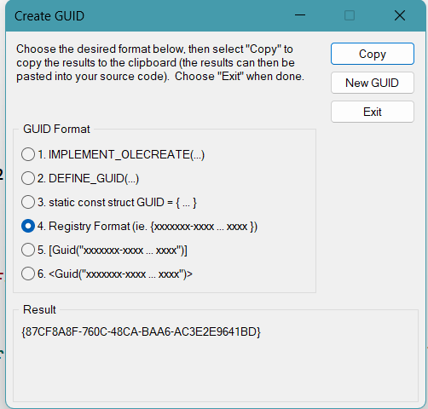

Build Settings
To ensure compatibility:
- Set Platform Target to x86 under: Project → Properties → Build → Platform target
- Optionally, set Assembly Version to AssemblyVersion("1.0.*")] and Sign the assembly by providing strong name file.

Release
Make sure to select Solution Configurations is set to ‘Release’ and build to generate YourConnector.dll in Release folder.

Deploying the Connector

Copy DLL and its Dependencies
Copy the following to the Power PDF installation directory: C:\Program Files (x86)\Kofax\Power PDF\bin\Connectors
- YourConnector.dll
- Any dependencies (e.g., System.Text.Json.dll if needed)

Modify PublishMode.xml
- This file to be updated in the following location:
- [Power PDF install folder]\resource\PowerPDF\UILayout\Publish Mode.xml
- Power PDF reads this file when loading connectors.
- It determines which UI actions are available to the user.
- All the entries added in Menu.cs mode should be added to this file itemID starting from 0
Eg:
Menu.cs

new MenuItemDefinition( ItemId.TryMe, "MenuTryMe", "", true, CallbackType.CALLBACK_MENUITEM,"Image_Open", "Image_Open_150", "Image_Open_200", "Image_Open_Small", "Image_Open_Small_150", "Image_Open_Small_200", true)

Corresponding change in Publish Mode.xml
These lines are added in the section <toolbar name="connectors" shortKey ="N">

<PFFGroup name="connector::CurrentDocumentBluePrint" GroupType="PFFTitleBlock" autoZip="0">
<PFFButton name="connector::tool::CurrentDocumentBluePrint:menuItem0"/>
</PFFGroup>

Add Group Name
  - Go to C:\Program Files (x86)\Kofax\Power PDF 51\Resource\PowerPDF\ENU
  - Open NameAndTitle.xml
  - Add an entry under <!--connectors toolbar--> like below
<PFFGroup name="connector::CurrentDocumentBluePrint" title="Blueprint" />
  - The title here will appear in PPDF as below
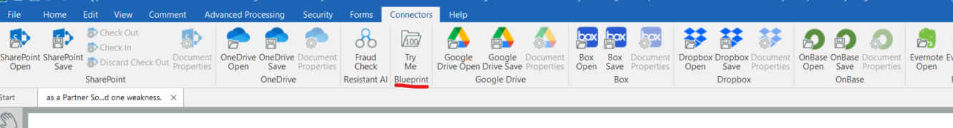

Register DLL
- Open Command Prompt with Administrator
- Run the following command
"C:\Windows\Microsoft.NET\Framework\v4.0.30319\regasm.exe" "C:\Program Files (x86)\Kofax\Power PDF 51\bin\Connectors\YourConnector.dll" /codebase

If you want to unregister for any reason use the below command
"C:\Windows\Microsoft.NET\Framework\v4.0.30319\regasm.exe" /unregister "C:\Program Files (x86)\Kofax\Power PDF 51\bin\Connectors\YourConnector.dll"

Troubleshooting step:
Registering the DLL will create a key in registry here.
HKEY_LOCAL_MACHINE\SOFTWARE\WOW6432Node\ScanSoft\Connectors\YourConnector.Connector

Clear Cache
Delete Publish.xml if available at this folder. %appdata%\Kofax\PDF\PowerPDF\UILayout\Publish.xml
Make sure to Restart Power PDF before testing the changes.

